MSSE 500 - Assignment Submission Document

Name: David Freeman

Date: Oct-1-2017

I. Assignment Name: Build and/or Modify: Collision Game

II. Learning Objectives:

* Be able to accept and utilize user input and keyboard and mouse operations in order to create an interactive game/webpage.
* Understand encoding, saving, decoding, and restoring from local storage using try and catch in order to save user data.

III. Abstract -

To create the collision game that I have I started with the code provided from Meyer, 2010, chapter 7 and modified it to meet this week’s requirements. To let the player know that they have hit a wall I used an alert. I had made the game to reset after hitting any walls and then changed that to allow hitting a wall once and on the second collision reset the game and tell the player that they have lost. To do this I have a variable set to 0 and on hitting a wall a switch statement checks if this was the first collision and if so allows the player to continue on and if not the game will be reset. I also made a delete button to remove a maze from local storage using localStorage.removeItem. I thought it could get hard to remember the names of the saved mazes so a button will show the names of the saved mazes by alerting the keys of the localStorage object. I also wanted to reset the canvas if the maze that was draw was not wanted so a button will do that by utilizing clearRect().

IV. Statement of Originality

For this game I started with the provided code from GitHub and began to modify the original code to meet the requirements in the assignment details. All of the work to modify the game was done by myself using prior knowledge, the course text, and online resources. I used MDN and W3 Schools for research.

IV.

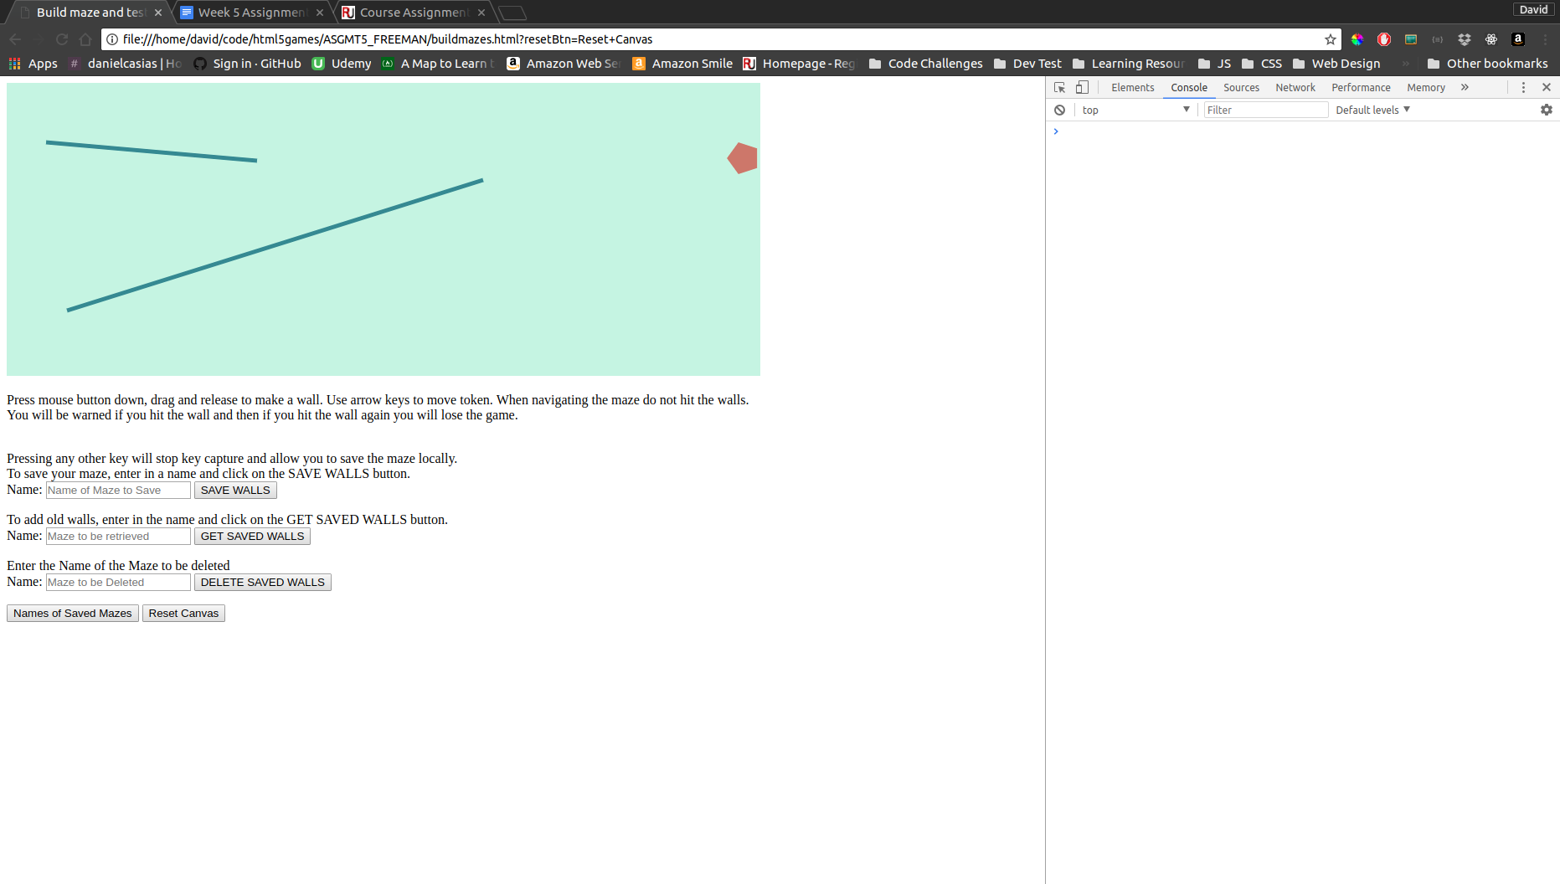

*Figure 1: Screenshot of Collision Game*

VI.

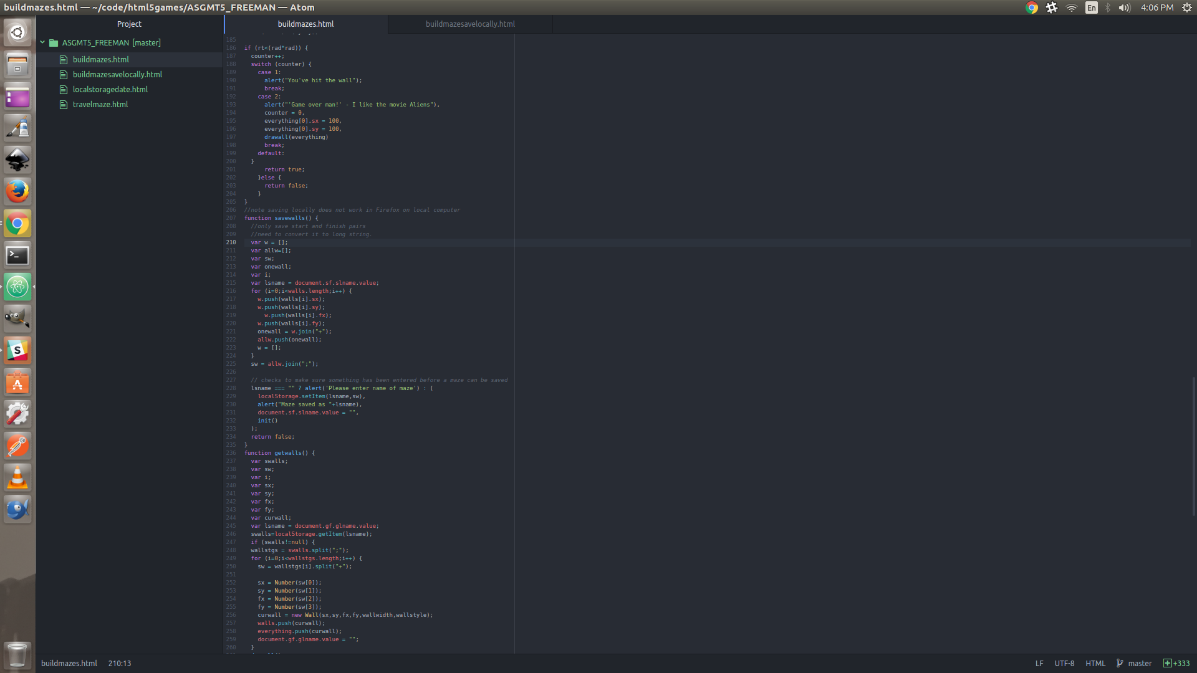

*Figure 2: Screenshot of code for Collision Game*

*Note: Original code from Meyer, 2010, chapter 7 Collision Game buildmazes.html*